Ramaiah Institute of Technology
(Autonomous Institute, Affiliated to VTU)

Department of CSE

Programme: B.E Term: Jan to May 2019
Course: Computer Organization Course Code: CS45
Activity V: Designing an ALU to perform arithmetic and logical functions using Logisim simulator.
Name: Nishanth S K | Marks: /10 | Date:20-05-2020
USN:1MS18CS085 | Signature of the Faculty:
Objective: To simulate the working of Arithmetic and Logical Unit using simulator.
Simulator Description: Logisim is an educational tool for designing and simulating digital logic circuits. With its simple toolbar interface and simulation of circuits as you build them, it is simple enough to facilitate learning the most basic concepts related to logic circuits. With the capacity to build larger circuits from smaller sub circuits, and to draw bundles of wires with a single mouse drag, Logisim can be used (and is used) to design and simulate entire CPUs for educational purposes.

Activity to be performed by students:

List out the steps in designing ALU
Step 1: Add the two input pins
Drop two East-facing input pins on the canvas 4-bits each. Label A and B, and ensure that each input is 4-bits.
Step 2: Add the Adder/ Subtractor and Gates
Now we add the sub-circuits creadted earlier. Select the circuits under the main
project folder.
Step 3: Add the Multiplexers
These take on or more data inputs and generate a single output. In Logisim,
multiplexers are under the Plexers folder. Click the Multiplexer icon and drop two of them onto canvas.

Step 4 : Add Controls
Drop two pins on the canvas, north-facing, with 1 data bit. Label them 0 and 1 , respectively.

Step 5: Add a Splitter
Next, we add a splitter into our circuit that takes one line from the second multiplexer and split to 4 inputs to an OR gate – for a 4-bit ALU.

Step 6: Add another OR gate And a NOT Gate
Now we add an OR gate after the splitter, which has 4 inputs . To
the right of the OR gate, add a NOT gate.
This arrangement accounts for Zero output when All of the bits result in zero.
The NOT gate following the OR gate achieves this.
Finally, add a single-bit pin after the NOT gate to store the result,Label it ZERO.

Step 7: Add a Result Pin for the MUX
We handled the zeros coming from the MUX, but we also need to account for valid combinations inputs from A, B, and the Control inputs.

SNAPSHOTS

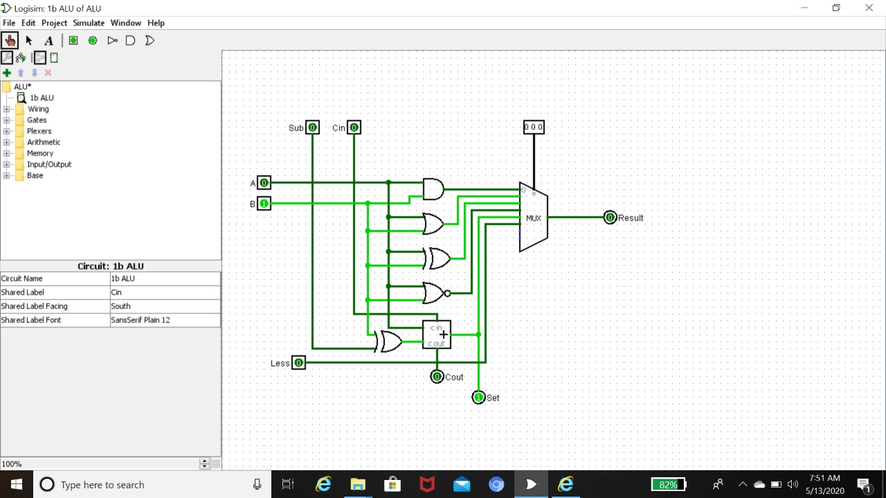

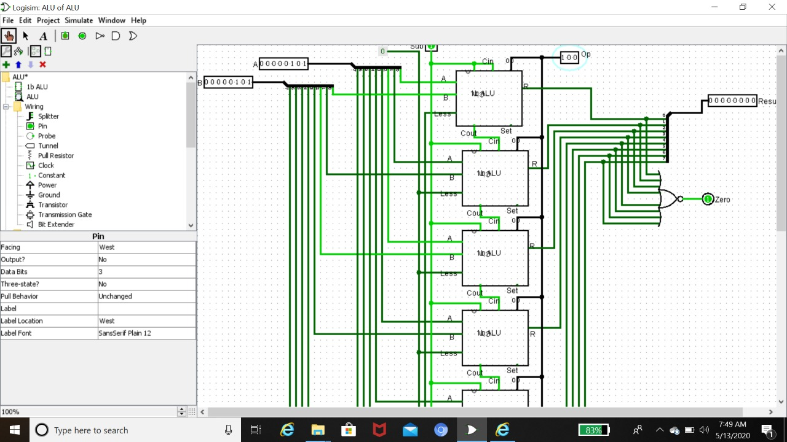

Ramaiah Institute of Technology
(Autonomous Institute, Affiliated to VTU)

Department of CSE

Programme: B.E Term: Jan to May 2019
Course: Computer Organization Course Code: CS45
Activity VI: Designing memory system using Logisim simulator.

Name: Nishanth S K | Marks: /10 | Date:20-05-2020
USN: 1MS18CS085 | Signature of the Faculty:
Objective: To simulate the writing operation on memory.
Simulator Description: Logisim is an educational tool for designing and simulating digital logic circuits. With its simple toolbar interface and simulation of circuits as you build them, it is simple enough to facilitate learning the most basic concepts related to logic circuits. With the capacity to build larger circuits from smaller sub circuits, and to draw bundles of wires with a single mouse drag, Logisim can be used (and is used) to design and simulate entire CPUs for educational purposes.
Activity to be performed by students:
List out the steps in designing memory system
Step 1 : Add RAM
Select a separate load and store operation for RAM
Step 2 : Add Counter
Connect Counter , Clock and Controlled Buffer to the RAM
Step 3 : Add TTY
To display the data
Step 4 : Add Random Generator
To generate different address location. Add input and another Controlled Buffer to the Random Generator.
Step 5 : Add Button
Connect Button to Counter.

Observations and Snapshots:
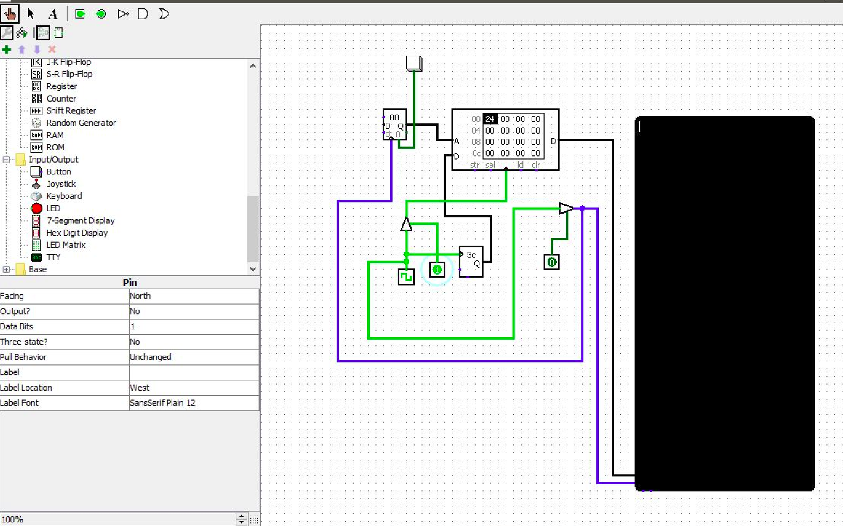

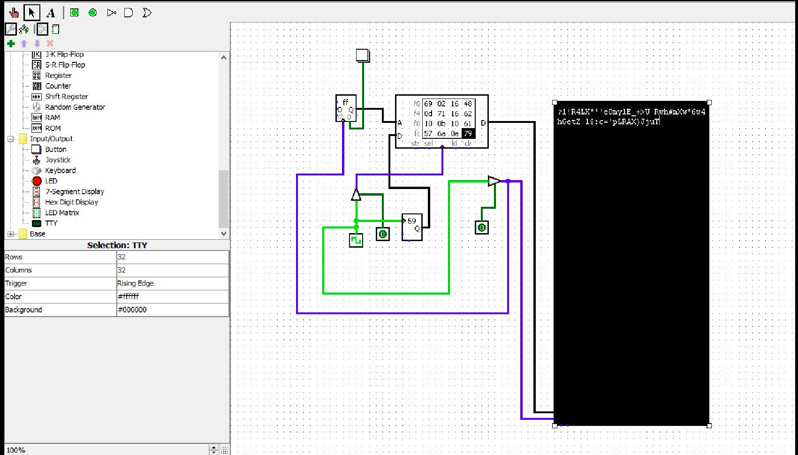

7
Ramaiah Institute of Technology
(Autonomous Institute, Affiliated to VTU)

Department of CSE

Programme: B.E Term: Jan to May 2019
Course: Computer Organization Course Code: CS45
Activity VII: To simulate advantages of using pipeline technique in executing a program.
Name: Nishanth S K | Marks: /10 | Date:22-05-2020
USN:1MS18CS085 | Signature of the Faculty:
Objective: To learn and analyze the performance of the CPU by overlapping of instructions using CPUOS-SIM simulator.
Simulator Used: CPUOS-SIM is a software development environment for the simulation of simple computers. It was developed by Dale Skrien to help users to understand computer architectures.

Modern CPU’s contain several semi-independent circuits involved in decoding and executing each machine instruction. Separate circuit elements perform each of these typical steps:
- Fetch the next instruction from memory into an internal CPU register.
- Decode the instruction to determine which function sub-circuits it requires.
- Read any input operands required from high-speed registers or directly from memory.
- Execute the operation using the selected sub-circuits.
- Write any output results to high-speed registers or directly to memory.

Separate sections of the CPU circuitry are used for each of these steps. This allows these circuit sections to be arranged into a sequential pipeline, with the output of one step feeding into the next step.

With diagram demonstrate the execution of the following instructions using pipelining technique.
lw $10,20($1)
sub $11, 42, $3
add $12, $3, $4
lw $13, 24($1)
add $14, $5, $6

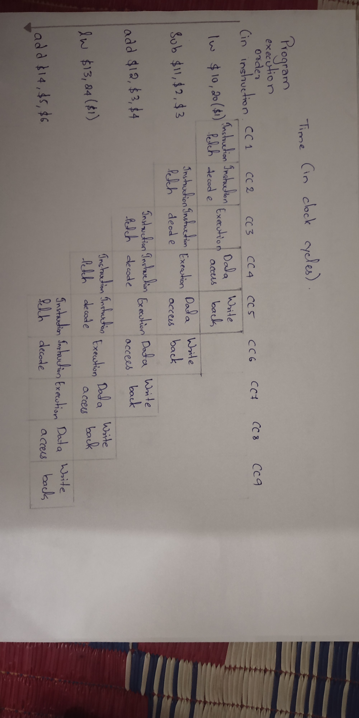

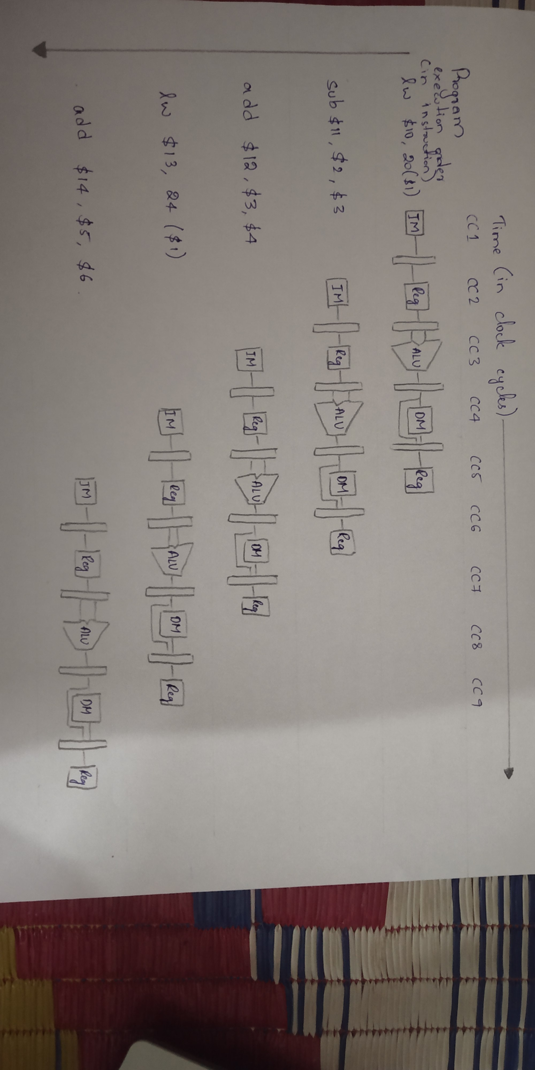

SNAPSHOTS
